SOCIOLOGY GRADUATE PROGRAM
REFERENCE GUIDE

September 2017

University of Kentucky
Department of Sociology
1515 Patterson Office Tower
University of Kentucky

This reference guide can be found at:
http://soc.as.uky.edu/graduate-student-reference-guide

The Graduate School Bulletin can be found at:
http://www.research.uky.edu/gs/CurrentStudents/Bulletins/current/bulletin -14-part1-final2.pdf

For any questions about this reference guide, please contact:

Dr. Ana S.Q. Liberato Director of Graduate Studies Department of Sociology University of Kentucky
1573 Patterson Office Tower

Lexington, KY 40506-0027
Phone: (859) 257-6069

Fax: (859) 323-0272
Email: aslibe2@uky.edu

The departmental policies outlined in this reference guide were approved in April 1998, April 1999, September 1999, December
1999, October 2001, March 2002, September 2002, November 2003, March 2004, November 2006, January 2009, January 2010, March 2010, January 2011, April 2011, November 2011, January 2012, October 2012, February 2013, March 2013, April
2013, April 2014.

Table of Contents

Introduction..................................................................................................................................................1

General Regulations of the Graduate School ................................................................................................ 2

Student Responsibility................................................................................................................................. 2

Graduate Courses ........................................................................................................................................ 2
Academic Load ........................................................................................................................................... 2

Grades and Grade Point Average ................................................................................................................ 3

Repeat Option............................................................................................................................................ 4
Transfer of Credits .................................................................................................................................... 4

Scholastic Probation .................................................................................................................................. 4

Readmission .............................................................................................................................................. 5
Termination............................................................................................................................................... 5

The Organization of Graduate Studies in Sociology ................................................................................... 6
Director of Graduate Studies..................................................................................................................... 6

DGS Administrative Associate.................................................................................................................. 6

The Department's Graduate Committee .................................................................................................... 6
Student Advisory Committees................................................................................................................... 6

Master’s Degree Programs .......................................................................................................................... 8

Core Requirements .................................................................................................................................... 8
Waiver of Core Requirements ................................................................................................................... 9

Additional Requirements........................................................................................................................... 9
Advisor/Advisory Committee ................................................................................................................... 10

PLAN A. ............................................................................................................................................... 10

PLAN B.................................................................................................................................................10
Written Product ......................................................................................................................................... 10

PLAN A: THESIS ................................................................................................................................. 10

PLAN B: NON-THESIS ....................................................................................................................... 11
Final Oral Exam ........................................................................................................................................ 11

Completed Copy of the Thesis/Written Product........................................................................................ 11

PLAN A. ............................................................................................................................................... 11

PLAN B.................................................................................................................................................11

Timing....................................................................................................................................................... 12
Annual Review/Advisory Meetings .......................................................................................................... 13

Progress Assessment of First Year Students.............................................................................................. 14
Time Limit for Master’s Degrees .............................................................................................................. 14

Admissions from MA to PhD……………………………………………….…………………………..14
Proposed revisions to the MA Curriculum………………………………….…………………………..15
Core Requirements……………………………………………………….…………………………..15
Plan Option……………………………………………………………….…………………………. 15
Final Examination………………………………………………………….……………………….. 16
Advisory Committee……………………………………………………….……………………….. 16
Special Provisions………………………………………………………….……………………….. 17
Doctor of Philosophy Program……………………………………………….…………………………18
Core Requirements…………………………………………………………….………………………..18
Course Credit Requirements…………………………………………………….………………………18
Research Requirements………………………………………………………….………………………19
Residence Requirement………………………………………………………….……………….……..19
PRE-QUALIFYING RESIDENCE REQUIREMENT……………………………………………….19
POST-QUALIFYING RESIDENCE REQUIREMENT……………………….……………………..20
Advisory Committee…………………………………………………………………………………….20
Annual Review…………………………………………………………………………………………..20
Progress Assessment of First Year Students……………………………………...……………………..21
Area of Specialization…………………………………………………………..……………………….23
Comprehensive Assessment Exam…………………………………………………..…………………..23
Qualifying Exam…………………………………………………………………………………………23
Pre-Qualifying Time Limit………………………………………………………………………………25
Time Limit for the Doctoral Degree……………………………………………………………….…….26
Dissertation………………………………………………………………………………………………26
Dissertation Proposal…………………………………………………………………………………….27
Final Oral Examination………………………………………………………………………………….27
Proposed Revisions to the Doctoral Program……………………………………………………………27
Core Requirements…………………………………………………………………………………….28
Advisory Committee…………………………………………………………………………………..28
Special Provisions……………………………………………………………………………………..29
Funding…………………………………………………………….……………………………………30
Philosophy of Funding………………………………………………………………………………..30
Assistantships and Fellowships……………………………………………………………………….30
Time Limits on Support……………………………………………………………………………….30
Adequate Progress and Priorities for Funding…………………………………………………………31
GRADES…………………………………………………………………………………………….31
REQUIRED COURSES……………………………………………………………………

…….. 31

ACADEMIC LOAD ..............................................................................................................................31
INCOMPLETES ....................................................................................................................................31

THESIS OR MAJOR PAPER ...............................................................................................................31
TA/RA PERFORMANCE .....................................................................................................................32

PROFESSIONAL ORIENTATION/ACTIVITY ..................................................................................32

Summer Teaching by Graduate Students ...................................................................................................32
PAY CATEGORY .................................................................................................................................32

ELIGIBILITY ........................................................................................................................................32

SELECTION PROCESS .......................................................................................................................32
MINIMUM REQUIREMENTS.............................................................................................................32

PRIORITY (IN ORDER).......................................................................................................................32
EVALUATION......................................................................................................................................33

IMPORTANT NOTE.............................................................................................................................33

Graduate Student Awards ............................................................................................................................33
Funding for Travel………………………………………………………………………………………...33

Appendices ..................................................................................................................................................34

Appendix A. Master’s Program Learning Outcomes ................................................................................34
Appendix B. Doctoral Program Learning Outcomes .................................................................................38

Appendix C. Degree Progress & Planning Form .......................................................................................39

Introduction

Welcome to the Department of Sociology at the University of Kentucky. You are now part of our academic enterprise and our future. Ours is a diverse academic program, which includes faculty members with primary appointments in the Colleges of Agriculture, Arts and Sciences, Education, and Medicine. It is our graduate program that brings us together in a common purpose. It is our responsibility to guide and evaluate your academic journey towards an advanced degree. It is your responsibility to rigorously apply yourself to the required tasks and to take the initiative in mapping your program.
This reference guide1 has been prepared to assist students in their orientation to the Department of Sociology, its faculty, and its operational procedures. This document is not intended to be the sole source of information. Rather, it should be viewed as complementary to the University of Kentucky Bulletin: The Graduate School.2 It is your responsibility to read these documents and be informed concerning all regulations and procedures required by the Graduate School and the graduate program in Sociology.
Advanced degrees in sociology are certifications that the person possessing them can carry out the analytical, conceptual, and methodological operations expected of a professional sociologist. An advanced degree is not merely a stamp of professional competence, but also testifies to the expectations on
the part of the faculty that the person receiving the degree will continue to grow and be productive in the field. As a result, both professor and student are "stamped" with each degree. Faculty members at the University of Kentucky make every effort to insure that those who receive advanced degrees in sociology are fully capable of meeting the standards of professional scholarship.
As a graduate student, you must assume responsibility for planning your program and you must take the initiative in securing advice from the faculty. Any carefully developed plan devised for a program will depend upon individual interests or goals.

1 Online version can be found at http://soc.as.uky.edu/graduate-student-reference-guide.
2 Online version can be found at http://www.research.uky.edu/gs/CurrentStudents/bulletin.html.

1

General Regulations of the Graduate School3

Student Responsibility

It is the student’s responsibility to be informed concerning all regulations and procedures required by the course of study being pursued. In no case will a regulation be waived or an exception granted because a student pleads ignorance of the regulation or asserts that information was not presented by advisors or other authorities. Therefore, the student should become familiar with the Graduate School Bulletin, including (1) the section presenting the requirements for degrees and (2) the specific program offerings and requirements.
The Director of Graduate Studies in the student’s major program should be consulted concerning course requirements, any deficiencies, the planning of a program, and special regulations. Programs may have degree requirements that are not listed in the Bulletin. It is to be noted that the Dean of the Graduate School interprets the Graduate School Bulletin. Only the Graduate Council may waive requirements stated in this Bulletin.

Graduate Courses

All courses numbered 500 through 799 may be counted for credit toward a graduate degree provided they are approved as an appropriate part of the student’s graduate program by the student’s graduate advisor or committee. Courses numbered 400G to 499G carry graduate credit for non-majors only. Courses numbered at the 800 or 900 level are normally not accepted for credit toward a graduate degree. Exceptions can be made if permission is granted by the Graduate Council to a program to offer specific professional courses as part of its academic program. Prior approval to take a course must be obtained from the Director of Graduate Studies, the Dean of the Graduate School and the dean of the professional college. Without such approval, professional courses may not be counted toward satisfying degree requirements. Courses numbered at the 600 or 700 level should be taught by members of the Graduate Faculty or by such other instructors as are approved by the Dean of the Graduate School.

Academic Load

The total semester or term academic load of a student is the sum of all credits and credit equivalents (e.g., graduate language courses, undergraduate courses, courses audited, etc.) being carried. The normal academic load of a graduate student during any semester is nine credit hours or equivalent. Under no circumstances may it exceed 15 credit hours or equivalent. During the summer term, the maximum academic load for the second summer term is nine credit hours, and for the first summer term it is four credit hours. The maximum academic load for any combination of the first and second summer terms is 12 credit hours. For the student who is a full- time teaching assistant or whose service to the University requires approximately 20 hours per week, the academic load shall not exceed 10 hours. This maximum may be increased to 12 hours for students with lighter service loads upon recommendation of the DGS and approval of the Dean of the Graduate School.
Students satisfactorily completing nine course credits, or equivalent, of graduate level work during a semester, are classified as full-time students by the University. Students satisfactorily completing five course credits, or equivalent, during a summer term are classified as full-time. Those completing less than

3 This section is from The Graduate School Bulletin, Part 1. January 2014.

these amounts are classified as part-time. Full-time students who fall below the minimum full-time equivalent as the result of failing or dropping one or more courses are reclassified as part-time students for that semester or term.

Grades and Grade Point Average

The official grades of graduate students are recorded in the Office of the Registrar. The following scale applies to grading in graduate courses:

A High achievement
B Satisfactory achievement
4 grade points per credit
3 grade points per credit

C Minimum passing grade 2 grade points per credit E Failure 0 grade points per credit I Incomplete See explanation below
S Satisfactory See explanation below
U Unsatisfactory See explanation below

D grades may not be awarded to graduate students. Graduate courses (400G-799) may not be taken
Pass/Fail.
A grade of I (incomplete) may be assigned to a graduate student if a part of the work of a course remains undone and if there is a reasonable possibility that a passing grade will result from completion of the work. All incompletes (I grades) must be replaced by a regular final letter grade within 12 months of the end of the academic term in which the I grade was awarded or prior to the student’s graduation, whichever occurs first. If an I grade has not been replaced within the allowable period, the University Registrar shall change the I grade to a grade of E on the student’s permanent academic record and adjust the student’s grade point average accordingly, unless otherwise approved because of exceptional circumstances by the Dean of the Graduate School upon recommendation of the DGS in the student’s program.
Instructors who assign an I grade must file with the student’s DGS information which includes (1) the name of the student, (2) the course number and hours of credit, (3) the semester and year of enrollment,
(4) specific information on the work to be completed before a final grade can be assigned, and the time
frame in which the specific requirements are to be met (not to exceed 12 months). Graduate students should consult with their DGS concerning procedures relative to the awarding of I grades and the conditions under which they may be removed.
• All I grades must be resolved to a regular letter grade before a student may sit for the final examination, or the qualifying examination for doctoral students. Exceptions to this rule will be considered in unusual circumstances, and require the approval of the Director of Graduate Studies and the Dean of the Graduate School.
• A grade of S (satisfactory) may be recorded for students in graduate seminars, independent work courses, and research courses which extend beyond the normal limits of a semester or summer term. This grade may not be given to a student in a course carrying credit if the student has done unsatisfactory work or failed to o a reasonable amount of work, in which case a grade of U (unsatisfactory) will be assigned. The project must be substantially continuous in its progress. All S and U grades must be removed prior to the final examination (or qualifying examination for doctoral students), except for those given in Residence Credit 748, 749, 767, 768, and 769, or in graduate courses which carry no credit.

Once a grade other than I, S, or U has been reported to the Registrar’s Office, it may not be changed unless an error was made at the time the grade was given and recorded, and then only upon the written unanimous approval of the instructor, the Registrar, and the Dean of the Graduate School.
An overall average of B (3.00) on all graduate work in the program must be attained before an advanced degree may be awarded. Graduate-level courses (numbers 400G-799) are computed in the graduate grade point average, with the exception of 400G courses in the student’s program.

Repeat Option

A student may repeat a graduate course and count only the second grade as part of the graduate grade point average. This action will be initiated by petition of the DGS to the Dean of the Graduate School, and may be used only once in a particular degree program or in post-baccalaureate status.

Transfer of Credits

Upon request of the DGS, a total of 9 hours (or 25% of regular course degree requirements) may be transferred into a master's degree program. A total of 9 hours (or 25% of the credit hours needed to fulfill the pre-qualifying residency requirement) may also be transferred into a doctoral degree program. The transferable hours include all post-baccalaureate work, graduate work taken at another regionally-accredited university or as a student in another graduate program at the University of Kentucky.
The doctoral transfer policy would NOT apply in cases where a prior master’s degree is being used to satisfy 18 hours of the pre-qualifying residency requirement.
The following rules also apply to credit transfer:
• Course credits applied toward a previously awarded graduate degree cannot be transferred.

• Transfer of independent work, research, thesis, or dissertation credit is not permitted.

• Short courses lasting fewer weeks than the number of credits may not be transferred.
• A student must have been in graduate status at the time the courses were taken in order for the courses to be transferable.
• A student must be in good academic standing at the time of transfer.

• Only courses assigned a B grade or better can be transferred.

Scholastic Probation

When students have completed 12 or more semester hours of graduate course work with a cumulative GPA of less than 3.00, they will be placed on scholastic probation. Students will have one full-time semester or the equivalent (9 hours) to remove the scholastic probation by attaining a 3.00 cumulative GPA. If probation is not removed, students will be dismissed from the Graduate School. Students who have been dismissed from the Graduate School for this reason may apply for readmission after two semesters or one semester and the eight-week summer term. If they are accepted by the program, admitted students will have one full-time semester or the equivalent (9 hours) to remove the scholastic probation by attaining a 3.00 cumulative GPA. Exceptions to this policy can be made only by the Dean of the Graduate School. Students placed on scholastic probation are not eligible for fellowships or tuition scholarships and may not sit for doctoral qualifying examinations, or masters or doctoral final examinations.

Leave of Absence/Readmission

Enrolled graduate students at the University of Kentucky that sit out for one or more semesters will need to complete a new application and pay the application fee in order to be considered for readmission. In many instances this requirement can be avoided by requesting a “leave of absence”. In addition to avoiding the application process, this status will allow the student to priority register in preparation for their return to UK.
Procedurally, students should contact their Director of Graduate Studies (DGS) to seek approval for the leave prior to the beginning of the semester in question. If approved, the DGS will contact their Graduate School admissions officer who will modify the record accordingly. No more than two consecutive and four total semesters in leave of absence status may be requested. Post-qualifying doctoral students are not eligible for the leave of absence. International students considering a leave of absence are strongly encouraged to discuss their plans with the Office of International Affairs, Department of Immigration Services prior to making a formal request.

Termination

The Dean of the Graduate School may terminate enrollment in a particular program for the following reasons:
• Scholastic probation for three enrolled semesters

• Having failed twice the final examination for the master’s degree or the qualifying examination

• In cases where the student’s Advisory Committee recommends termination after the qualifying examination has been passed, the Graduate Faculty in that program will meet to vote on the recommendation. When the Graduate Faculty of that program concurs and the student dissents, the student will have an opportunity to meet with the Graduate Faculty of the program, after which a second vote will be taken and a final recommendation will be made to the Dean of the Graduate School.
The Department may terminate enrollment in a particular program for the following reasons:

• Having failed twice the comprehensive assessment for the doctoral degree;

• Having earned two C’s or below in Sociology graduate courses;

• Having earned three U’s in thesis writing or doctoral residency credit courses;

• Having received two “unsatisfactory” progress reviews from the Graduate Faculty;
• Having been found guilty of an academic offense or ethical misconduct, as specified in University
Senate Rules (6.3.0, p. 167).

• Students who fail to enroll in required residency credit courses will be dropped from the program;
such students must re-apply for admission in order to complete their degrees.
Sociology’ s Departmental termination procedures are as follows:
• Terminations will be decided by a majority vote of the Sociology Graduate Faculty.

• Letters of termination will be written by the Director of Graduate Studies and delivered to the student via registered mail; in cases in which the DGS is the student’s Advisor, letters will be written by the Chair.
• Students who dissent may meet with the Graduate Faculty of the program, after which a second vote will be taken and a final recommendation will be made to the Dean of the Graduate School.

The Organization of Graduate Studies in Sociology

Director of Graduate Studies

The Department grants Master’s and Doctor of Philosophy degrees in Sociology. The Director of Graduate Studies (DGS) is the official representative of the Graduate School. The DGS, with the help of the Department's Administrative Associate, administers the graduate program. The DGS reports to the Graduate Dean and is responsible for implementing the rules, procedures and policies of the Graduate School. If special circumstances warrant, a student may petition the DGS on all departmental requirements stated in this reference guide.

DGS Administrative Associate

The DGS Administrative Associate (DAA) provides assistance to the DGS by maintaining records of graduate students. Any changes in the student’s records need to be submitted to the DAA. Those forms that require DGS’s approval must be submitted to the DAA to be forwarded to the DGS for signature.

The Department's Graduate Committee

The Department's Graduate Committee provides guidance and assistance to the DGS. This committee includes the DGS as Chair, two or three other faculty members representing the Department, and one graduate student. This committee, excluding the student member, advises the DGS on admissions, assistantship and fellowship awards, petitions for waivers of requirements and makes the final decision on terminations from the program. The full committee reviews graduate program policy, examines curriculum changes, and when necessary implements Department rules and procedures pertaining to the graduate program. However, all changes in the graduate program must be approved at a Department’s Graduate Faculty meeting.

Student Advisory Committees

The most important committees in a student's academic life are the Academic Advisory Committees. Upon entering the Department, the DGS will act as your advisor. The DGS will evaluate your previous experience and help you work out a general plan of coursework. If you have had little or no previous training in sociology or other social sciences, it may be necessary to make up deficiencies in lower level courses without receiving graduate credit in these courses. In consultation with faculty who teach the relevant courses, the DGS will also determine whether prior course work can be substituted for required Department courses. The DGS appoints an interim advisor for each entering graduate student based upon the student’s expressed interests in sociology. During your first year, your interim advisor will provide guidance and listen to your concerns. A primary task for you and your interim advisor is completing the Master’s or doctoral Degree Planning and Progress Review Form (or DPPR Form). When completed, this sheet will be placed in your permanent file in the office of the DAA.
The Department strongly recommends that you form your Advisory Committee by the end of your first year or even earlier. It is your responsibility to ask the appropriate faculty to serve on your committee. There is no obligation for the interim advisor to serve on your Advisory Committee. A

faculty member may choose not to serve on your committee. Until you have formed an Advisory Committee, the interim advisor will perform Advisory Committee duties such as conducting the annual review of graduate student progress (see below).
Graduate students must be mindful that most Graduate Faculty members in Sociology have a 9 months-appointment. Between May 15 and August 15, graduate students are therefore discouraged from scheduling any advising meetings or examinations required for a Master’s or doctoral degree (e.g., qualifying examination, thesis/dissertation defense). If students need to schedule an oral examination during the summer break, they must request permission in writing from every Advisory Committee member BEFORE the final examination week of the spring semester. Then, the students must submit a request to the DGS for scheduling the examination.
For a Master’s degree, the Graduate School requires an Advisory Committee of three members. At least one member must be a Full member4 of the Graduate Faculty and one other must hold at least an Associate appointment. If the student so desires, one member of the committee (other than the Chair) can be a faculty member from a department other than Sociology.
For a doctoral degree, the Graduate School requires a core of four members.5 This core consists of the Major Professor as Chair (or two Co-Chairs), two other members from Sociology, and at least one representative must be from outside the Department. All members of the core must be members of the Graduate Faculty of the University of Kentucky and three (including the Major Professor) must possess Full Graduate Faculty status. If you would like an Associate member of the Graduate Faculty to serve as Chair of a Ph.D. committee, then a full member of the Graduate Faculty must serve as a co-Chair (see the Graduate School Bulletin for an explanation of Graduate Faculty Status and a listing of Sociology faculty who are full and associate members of the Graduate Faculty). Faculty members who do not hold Graduate Faculty status may serve as non-voting members of the Advisory Committee.
The core of the Advisory Committee must be kept at its full complement throughout the graduate career of the individual student. Thus, in the event of a vacancy on the Committee (occasioned by resignation, faculty leave, or inability to serve), an appropriate replacement must be made prior the making of important committee decisions such as the Master’s thesis defense or doctoral qualifying examination.
Your Advisory Committee will provide guidance throughout your graduate career. The Chair (or co- Chairs) is (are) expected to direct your thesis, major paper, or dissertation, and to provide mentoring throughout your graduate program.
Doctoral students establish their official Advisory Committee by submitting on-line “Doctoral Advisory Committee Request” form to the Graduate School at http://www.research.uky.edu/cfdocs/gs/DoctoralCommittee/Selection_Screen.cfm. It is possible to change the composition of the doctoral committee, but any change requires the approval of the DGS. In the case
of a failed qualifying exam or dissertation defense, the approval of the Dean of the Graduate School is required. Master’s students do not petition the Graduate School to form their committees, but are required to fill out and submit a departmental form which lists their committee members. Choosing your committee is one of the most important acts you make as a graduate student.

4 Generally speaking, “Full Graduate Faculty” are those faculty members with tenure, who hold a rank of either “Associate Professor” or “Full Professor.” “Associate Graduate Faculty” tend to untenured faculty members with a rank of “Assistant Professor.” When you are not sure whether a particular faculty member holds “Full” or “Associate” status in the Graduate School, please check the Graduate Faculty Directory at https://www.research.uky.edu/cfdocs/gs/dgsgradfac/ or contact the DGS.
5 Any student who passed the oral qualifying examination prior to May 1, 2001 must maintain an Advisory
Committee core of five members rather than four.

Master’s Degree Programs

Two Master’s degrees are offered, including: (1) the Master of Arts in Sociology (M.A.) and (2) the Master of Science in Agriculture (M.S. in Agriculture) with Rural Sociology Concentration. Either degree may be obtained on a thesis basis (Plan A) or a non-thesis basis (Plan B). Students should indicate their choice of degree and plan to the DGS no later than the end of their second semester. Students may change
to a different option at a later time with the approval of their Advisory Committee and the DGS.

IMPORTANT NOTES: In the effort to streamline the Master’s and doctoral degree programs, the
Sociology Department will stop admitting students into the Master’s program from the fall semester of
2015. If the curriculum revisions are approved, the MS in Agriculture option and Plan A option for the
MA degree will be also eliminated. Those who entered into the Master’s program in the fall semester of
2013 or 2014 are strongly encouraged to complete the Plan B option.

Core Requirements

Core Departmental and Graduate School requirements are the same for either the Master of Arts or Master of Science in Agriculture degrees. The following courses are required in the core areas of theory, methods, and statistics. These are minimum requirements; more work may be required in certain cases.
Theory (3 credit hours)
SOC 650 3 Concepts and Theories in Sociology (Fall)†

Prerequisite: SOC 304 and 305 or equivalent
Statistics (6 credit hours)
SOC/PS 572 3 Quantitative Analysis I (Fall)

Prerequisite: SOC 303 or STA 570
SOC/PS 681 3 Research Design Analysis (Spring)
Prerequisite: SOC/PS 572

Methods (3 credit hours) SOC 682 or any other methods courses

3 Any approved Methods course(s) for 3 credit hours
(e.g., survey, qualitative, networks)

Prerequisite: SOC/PS 572

IMPORTANT NOTES: Due to staff turn-over which delayed approval of proposed program changes, this is our second transition year to the revised curriculum. We did not admit Master's students in 2015. By the end of this academic year, we will finalize the program changes, new curriculum and course
numbers.

These requirements are satisfied if a minimum grade of “B” is achieved in the requisite courses. If this minimum course grade is not achieved, the required course or its equivalent must be retaken and passed with a minimum grade of “B.” Only credit hours achieved with a “B” or above are counted in Master’s credit hours requirements.

Waiver of Core Requirements

If equivalent coursework has been taken elsewhere, during the first academic year students may petition the DGS for a waiver of required theory or methods courses. Evidence of equivalence consists of a syllabus or other document from the equivalent course that shows parallel content in addition to transcript documentation of satisfactory completion of the course with a grade of “B” or better. The DGS is the final arbiter of a waiver decision. Action may be taken in consultation with the Graduate Committee, the student’s Advisory Committee, and/or instructors of required theory and methods courses if questions arise about equivalency criteria. Only signed approval letter from the DGS consists as an evidence of waiver of a core requirement.

Additional Requirements

Requirements include a thesis and completion of at least 24 semester hours of course work with a cumulative standing of 3.0 (“B”) or better. Two-thirds of the 24 hours of course work must be in Sociology, and three-quarters of the courses must be at the 600-level or above. (The minimum of 24 hours of course work includes the 9 hours of required courses in theory and methods/statistics.) The department requires students to submit a written thesis proposal and defend it orally as part of the Plan A option.
Because the Department has decided to phase out Plan A Thesis Option by the fall semester of 2015, those students, who entered into the program in the fall semesters of 2013 and 2014 are strongly encouraged to pursue the Plan B Paper option in lieu of a thesis. Research papers can often be completed in a more timely manner and, equally important, are likely to be of a publishable length and scope. Moreover, it makes a transition to our proposed PhD Program easier.
Requirements under Plan B include a written product and completion of at least 30 semester hours of course work for the Master of Arts and 36 semester hours for the Master of Science with a cumulative standing of 3.0 (“B”) or better. Two-thirds of the course hours must be in Sociology, and three-quarters of the courses must be at the 600-level or above. In addition, the Graduate School stipulates that two-thirds of the minimum course requirements be in regular courses, as opposed to special problems or independent research. (The minimum hours of course work listed above includes the 9 hours of required courses in theory and methods/statistics.) The department requires students to submit a written paper proposal and defend it orally as part of the Plan B option.

Required Hours Plan A (MA) Plan B (MA) Plan B (MS)

Course Work and Written Product

Minimum Sociology Courses
24 + Thesis

16
30 + Research Paper

20
36 + Research Paper

24

Minimum 600+ courses 15 15 18

Minimum Regular Courses 16 20 24

Advisor/Advisory Committee

PLAN A.
As noted above, after identification of the general subject area for the thesis, students should select, in consultation with their interim advisor and the DGS, a faculty member to ask to serve as Advisory Committee Chair and thesis director. If the person agrees to serve in this capacity, the DGS must be notified so that the appointment can be confirmed and recorded. The Advisory Committee Chair should be appointed by the end of the second semester of residence. In consultation with the Advisory Committee Chair, the student asks two additional faculty members to serve on the student’s advisory (thesis) committee. At least one member of the Committee must be a full member of the Graduate Faculty; another should be a full or associate member. This committee will guide the student in the
completion of the program and serve as the final oral examination committee. As noted above, the student must fill out and submit the departmental form which lists the committee members when the committee
has been formed. (See the section below pertaining to Annual Review/Advisory Meetings.)

PLAN B.
The student should discuss with the interim advisor and the DGS the selection of a Chair and two other appropriate faculty members to serve as an Advisory Committee. The DGS will formally appoint the committee. This committee will guide the student in the completion of the program and serve as the final oral examination committee. (See the section below pertaining to Review Meetings.)

Written Product

A written product is required of all Master’s degree candidates. This product will take the form of a thesis for students selecting Plan A. Students selecting Plan B will be required to submit a research paper or other written product as agreed upon with the Advisory Committee.

PLAN A: THESIS
Topic. The Master’s thesis is intended to be a relatively limited research exercise on a focused and manageable topic. It does not have to be a completely new contribution to knowledge. It can be a restudy of an earlier investigation or an attempt to extend an established hypothesis. It should be focused on a
well- defined topic with restricted scope. At the same time, it must be carried out with care and rigor.
Proposal. When the student and the Advisory Committee Chair feel that the student’s thesis plans have been sufficiently developed, the student will draft a formal proposal, in consultation with other members of the Advisory Committee. The student will then schedule a meeting of the Advisory Committee for the formal proposal hearing.
The proposal hearing is chaired by the Advisory Committee Chair and all members of the Sociology faculty are invited and given the opportunity to comment on the proposal. At the conclusion of the hearing, the Advisory Committee will vote to approve or disapprove the proposal.
• If approved by a majority, the title page of the proposal will be signed by all members of the Advisory
Committee.

• The Advisory Committee Chair will transmit the signed proposal to the DAA to be permanently placed in the student’s file.
• If approval of the proposal is not given, another proposal hearing, which follows the same schedule requirements as the first hearing, must be held after suitable revisions.

Writing the Thesis. The student’s Advisory Committee Chair will supervise the student’s work during preparation of the thesis, with the Chair taking major1.
• The thesis must be prepared in the format used in journals published by the American Sociological
Association.

• The student must consult the Office of Admissions and Records in the Graduate School and follow
that office’s requirements regarding the thesis format.
Enrollment Requirement. Master's candidates working on their theses may register for up to 12 credits of course number 768 in the appropriate department. Plan A master's degree candidates who are in residence and receiving financial support from the University and/or utilizing University resources while working on the thesis must be enrolled in the Graduate School. Candidates not enrolled in course work to meet degree requirements must be enrolled in their department's course number 748 or 768 each semester.

PLAN B: NON-THESIS
Under Plan B, the written product most often takes the form of a research paper, policy paper, or evaluation paper. This manuscript needs not be judged “publishable” but must be based on extensive independent research and conform to scientific standards. It may have an applied or program-planning or
- evaluation orientation. The non-thesis paper option has the same proposal and defense procedures as the thesis option, outlined above. The documents differ primarily in scope and length. A paper is typically approximately 30 pages in length while a thesis is approximately 50-80 pages in length and has a multiple chapters.

Final Oral Exam

A final oral examination is required of all Master’s candidates and is conducted by the student’s three- person Advisory Committee. Upon completion of the thesis/other written product described above, the student should arrange in consultation with the DGS and their committee a suitable time and place for the examination.
The exam includes, but is not limited to, a defense of the written product. A majority vote of the full committee determines the outcome of the exam. In the event of a failure of the final exam, a second exam will be scheduled if recommended by the student's committee and if approved by the Dean of the Graduate School. A third exam is not permitted.
Upon passing the final oral examination, the student has 60 days from the final exam date to make any revisions, additions, and corrections required by the examining committee, and to deliver two copies of the thesis in final form to the Graduate School, with the signatures of the Thesis Director and the DGS.

Completed Copy of the Thesis/Written Product

PLAN A.
The student must supply to the DAA one unbound copy of the thesis for the Department library. (This is in addition to the two unbound copies required by the Graduate School.)

PLAN B.
The student must deliver a final copy of the written product to the DAA to be placed in the student’s
permanent file.

Timing

Students should identify a topic and start work on a thesis or other written product ideally by the end of the second semester in residence. In any case, this decision must be made by the end of the semester prior to the one in which the student expects to receive the degree. For full-time students, the written product should be completed by the end of the fourth semester. The following rule is intended to encourage timely completion of the Master’s degree:
Before a student’s Master’s degree requirements (including the thesis) are completed, a candidate for this degree is permitted to register for or take no more than six semester hours of course work beyond the specified number of hours required for the Master’s degree.
The student’s Advisory Committee Chair may petition the DGS to allow an exception of a specified number of hours. Only if recommended by the DGS and approved by the Graduate Committee would additional hours be allowed. Students should also note the Departmental policy limiting assistantship or fellowship financial support for Master’s degree candidates. (See the section on Time Limits on Support below).

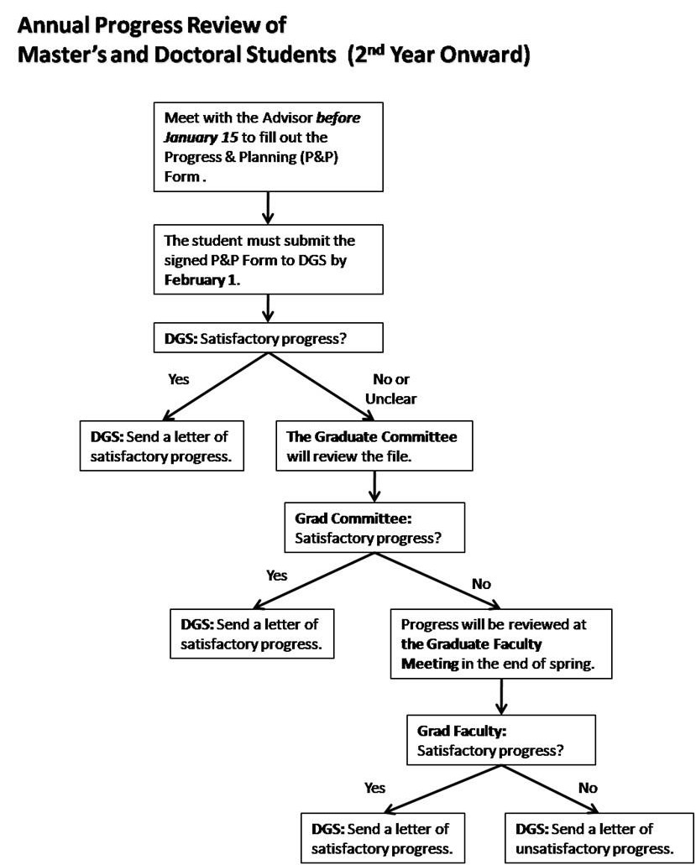

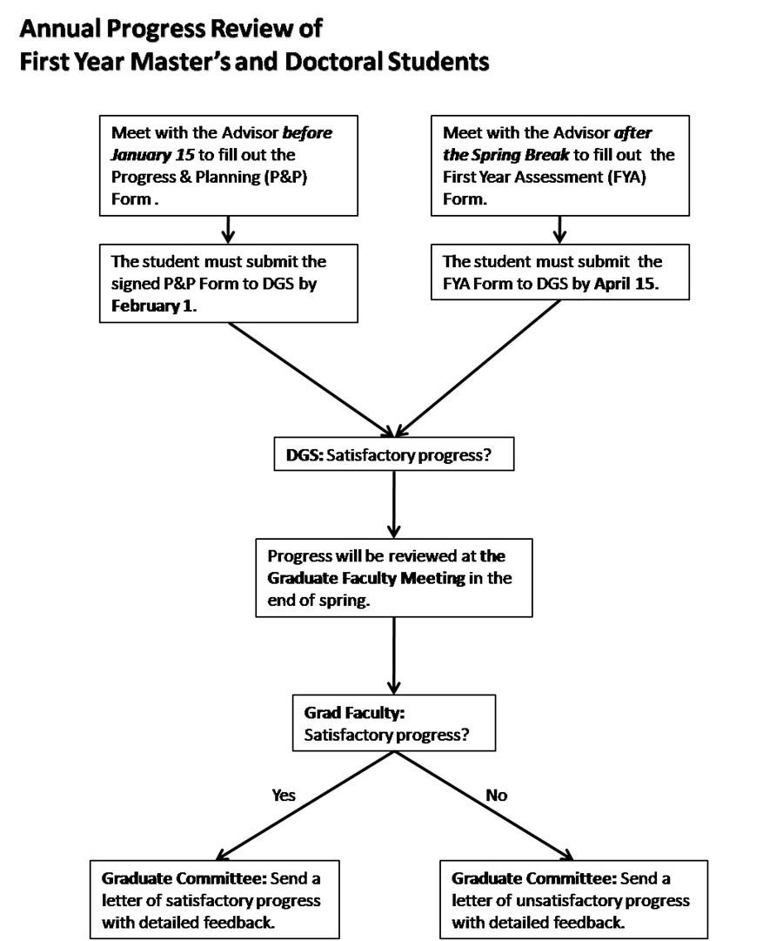

Annual Review/Advisory Meetings

To facilitate students’ progress in the program, Master’s students are required to meet with their interim advisor or Advisory Committee at least once a year to complete an annual progress review. This review should be completed between the finals week of Fall Semester and February 1 during the student’s first year in the program. To facilitate this review, students should fill out or update the Master’s DPPR Form (available from the DAA), listing the courses taken to date, grades received, and other information related to degree progress (e.g., thesis proposal defense plans, thesis defense plans). One copy shall be filed with the DAA, one copy should be sent to the DGS, and other copies distributed to the advisor and committee members.
It is important that this document be filed by February 1, as information about student progress is used to evaluate requests for continued departmental financial assistance (teaching and research assistantships) for the coming academic year.

DPPR Forms will be reviewed by the DGS. Students without any problems will receive a letter of satisfactory progress by the DGS. In the event that problems in student progress are noted, the Graduate Committee will review his/her file and recommend a necessary course of action. When a Departmental discussion seems warranted, the Graduate Committee may decide to schedule a Graduate Faculty meeting at the end of the spring semester to discuss graduate student progress. The DGS will write a letter to the student and her/his advisor informing them of the Graduate Faculty’s concern and inquiring about steps the Department might take to address the problem.

Progress Assessment of First Year Students

First year Master’s and doctoral students normally do not have much information to be evaluated in the beginning of the spring semester. Besides the DPPR Form to be submitted to the DGS by February
1, they are required to submit to their advisors by the first day after the Spring Break a brief personal narrative statement which reflects on student progress in the graduate program. The advisors then write their brief responses to the statements and schedule a meeting with each of the advisees to discuss the document and address any questions and/or concerns that the advisees may have about the graduate program, degree requirements, professional development, and etc. Student’s personal narrative statement and the response of his/her advisor must be submitted to the DGS by April 15.
The Graduate Committee will schedule a Graduate Faculty meeting at the end of the spring semester to discuss their progress. The Graduate Committee will provide more detailed feedback to these students at the early stage of their graduate student career at the University of Kentucky and suggest any adjustments necessary to improve their performance.

Time Limit for Master’s Degrees

Students first enrolled in a Master’s program in the fall 2005 semester and beyond will have 6 years to complete all requirements for the degree, but will still have the opportunity to request extensions up to an additional 4 years for a total of 10 years. Extensions up to 2 years may be approved by the Dean of the Graduate School. Requests for extensions longer than 2 years must be considered by Graduate Council.
No activity completed more than 12- or for new students 10- calendar years preceding the proposed graduation date as appropriate will be considered for graduation.

Admission from Master’s to Ph.D. Program in Sociology

ALL the existing Master’s students nearing completion of the Master’s degree who wish to continue in the Department’s graduate program must apply for admission to the doctoral program before January
15. Students who have not been continuously enrolled in the University of Kentucky must reapply for admission to the Graduate School before January 15. To be considered for admission to the Ph.D. program, each student must submit: (a) a time-line for the completion of his/her Master’s degree program, (b) a statement of purpose for his/her Ph.D. program, and (c) two recommendation letters, including one from his/her Advisor which assesses the student’s performance in the Master’s program and provides the Advisory Committee’s recommendation regarding whether the student should be admitted to the Ph.D. program. Student admission from the Master’s to the Ph.D. program shall be officially registered in the student’s Graduate School record AFTER the student has successfully defended the Master’s thesis.

Important Note: From the fall semester of 2015, all new students will be admitted to the doctoral program, and thus making this requirement mute.

Proposed Revisions in the Master’s Curriculum

During the 2015-16 academic year, the University will review our proposals to revise the Master’s and doctoral programs in Sociology. Students who entered the program in prior to the approval date can choose to complete the program either the current or new requirements. As stated above, the Master’s of Science in Agriculture with Concentration in Rural Sociology will be eliminated. The proposed revisions in the MA in Sociology include:
1. Plan A Option will no longer be offered.
2. Students must complete a total of 36 hours of coursework, including: (a) 18 hours for the core courses in Theory, Methods, and Statistics, (b) 3 hours for research design and practicum, and (c) 15 hours for electives.
3. Students must pass the preliminary (or comprehensive assessment) examination on sociological theory and social statistics during the second year.
4. Students must also successfully defend their 2nd year research paper (in journal-length) by the end of the second year as the final examination.

Core Requirements

Course  No. | Course Title | Hrs | Semester  Offered Prerequisite
SOC 680 | Social Investigation | 2 | Fall | SOC 681, SOC 781, SOC 651, SOC 751
SOC 681 | Quantitative Data Analysis I | 3 | Fall | Undergraduate statistics course
SOC 781 | Quantitative Data Analysis II | 3 | Spring | SOC 681/PS 572
Various | Any approved method course(s) | 6 | Various | SOC 681/PS 572
SOC 651 | Classical Sociological Theory | 3 | Fall | Undergraduate theory course
SOC 751 | Contemporary Sociological Theory | 3 | Spring | SOC 651

Plan Option
The Graduate Program in Sociology will offer only Plan B in the Master’s degree program. As stated above, we will eliminate the MS in Agriculture as a degree option. We will also eliminate Plan A from
the Master’s degree program. Requirements under Plan B will remain as a written product and completion
of at least 30 semester hours of course work for the Master of Arts with a cumulative standing of 3.0 (“B”) or better. Two-thirds of the course hours must be in Sociology, and three-quarters of the courses must be at the 600-level or above. In addition, the Graduate School stipulates that two-thirds of the minimum course requirements be in regular courses, as opposed to special problems or independent research. (The minimum hours of course work listed above includes the 9 hours of required courses in theory and methods/statistics.) The department requires students to submit a written paper (the final product of SOC 680) and defend it orally as part of the Plan B option.

Required Hours Plan B (MA)

Course Work 30

Minimum Sociology Courses 20

Minimum 600+ courses 15

Minimum Regular Courses 20

Final Examination Research Paper Defense

Final Examination
In order to streamline the Master’s and PhD degree programs, the purpose and required components of the final examination need to change. Since all graduate students will be admitted to the PhD degree program from the fall semester of 2015, the Master’s final examination process must be restructured to determine which students will exit our program with a Master’s degree and which ones will proceed in the doctoral degree program. To achieve that goal, we will require all graduate students to take the Comprehensive Assessment Examination, offered in the fall semester of the second year, and complete the second year paper (or Plan B paper) as the final examination.
1. Comprehensive Assessment Examination. In the beginning of the fall semester of the second year, all the students must take the comprehensive assessment exam to test their knowledge and skills in sociological theory and social statistics. The result of the comprehensive assessment exam will be: (a) Pass to move up to the doctoral level, (b) Pass to graduate with the Master’s level, and (c) Fail. If they fail
in the first try, students can retake the exam in the end of the 2nd fall semester to pass to graduate with the
Master’s level or to move up to the doctoral level. In the spring semester of the second year, all the students, who passed the Comprehensive Assessment Exam, must complete the second year research paper (see below).
2. Second Year Research Paper. The final examination of the Master’s degree consists of successful oral defense the second year research paper, which “must take place no later than eight (8) days before the last day of classes of the semester in which the degree is to be awarded” (The Graduate School Bulletin Part 1, p. 46). This second year paper will be used to assess students’ understanding of sociological theory and methods and research skills as well as their knowledge on the content. Only those students who complete the second year paper can continue with the doctoral program in Sociology. Students who wish to obtain a MA degree or exit from the program with a MA degree must use the completion of the second year paper as the Final Examination for MA degree in Sociology.

Advisory Committee
Each student working on the 2nd year paper must form a Master’s degree advisory committee by the end of the second fall semester, “which consists of at least three qualified faculty members recommended by the Director of Graduate Studies and appointed by the Dean of the Graduate Faculty.” The advisory committee must consist of: (a) that student’s faculty advisor, (b) the faculty instructor of the SOC 680/780 sequence, and (c) a faculty reader from either SOC or any other program, appointed by the DGS in consultation with the DGS and student and his/her advisor. This will allow for a more fair distribution of graduate committee assignments among the SOC graduate faculty since the DGS has complete information about the distribution of faculty committees at any given time to redistribute a graduate committee load more fairly among SOC graduate faculty.

Advisory Committee:
Each student working on the 2nd year paper must form an advisory committee by the end of the second fall semester. The advisory committee must consist of: (a) that student’s faculty advisor and b) two additional faculty that conform to the Graduate School regulations regarding advisory committees for MA degrees. The faculty advisor is encouraged to consult with the DGS when selecting the sociology faculty reader as a means to allow for a more fair distribution of graduate committee assignments among the SOC graduate faculty.
About Students who wish to obtain a MA degree or exit from the program with a MA degree
Only students who wish to obtain a MA degree or exit from the program with a MA degree must have their advisory committee formalized by the Graduate School and conduct a formal examination, all following Graduate School guidelines and deadlines.

Special Provisions
Waiver. Students who have completed a MA/MS in Sociology in another program can request a waiver for the core course requirements to DGS. DGS will conduct an initial review to determine what documentations need to be submitted by the student. Then, the Graduate Committee will review the documents to determine whether or not to approve the waiver request. Even with course waiver(s), all students are required to take and pass the Comprehensive Assessment Exam.
Part-Time Students. Part-time students are allowed to take SOC 680/780 sequence AFTER their successful passing of the Comprehensive Assessment Examination. It is strongly advised that part-time students take the Exam by no later than the fall semester of the third year in order to meet the 5-year pre- qualifying time-limit set by the Graduate School. They must discuss with both DGS and their major advisors about the timing of fulfilling the second year paper.

The Doctor of Philosophy Program

All Ph.D. work in sociology is under the direction of the Department of Sociology and the Graduate School. The Department offers the Ph.D. in Sociology, with faculty expertise and graduate courses concentrated in the following areas:
• Crime, Law and Deviance

• Global Work and Politics

• Rural, Environmental, and Community Sociology

• Health and Medical Sociology
• Social Inequalities: Class, Race, Gender
Ph.D. students develop one 12-hour area of specialization. This specialization area is not required to conform completely to the concentration areas listed above; however, it should be closely related to them. For example, a student might focus on Political Sociology, a subset of Global Work and Politics. Another student might focus on Criminology, a subset of Crime, Law and Deviance. Considerable flexibility exists to create a program of study and research tailored to individual student interests. The specialization area may be composed of both Sociology and non-Sociology courses. However, at least 12 of the required 21 non-core credit hours must be taken from within Sociology.
The Department of Sociology offers Ph.D. students many opportunities for professional development to integrate them into the profession and to prepare them for their future careers as sociologists. Opportunities exist to work as research assistants on funded faculty research projects and/or applied sociology outreach programs and to develop teaching skills through employment as teaching assistants. Additional professional development experiences are offered through seminars and workshops organized by the department’s Professional Development Committee and other university-wide professional
development programs.

IMPORTANT NOTES: From the fall semester of 2016, the Master’s and doctoral degree requirements will be streamlined. Those who entered into the doctoral program in the fall semesters of 2013-15 are
strongly encouraged to follow the revised curriculum.

Core Requirements

Theory (6 credit hours)  SOC 651 | 3 | Classical Sociological Theory (Fall)
 |  | Prerequisite: Undergraduate theory
SOC 751 | 3 | Topics in Contemporary Sociological Theory (Spring)  Prerequisite: SOC 651 or equivalent
Statistics (6 credit hours)
SOC/PS 572 | 3 | Advanced Quantitative Analysis 1  Prerequisite: Undergraduate statistics
SOC 681/PS 672 | 3 | Research Design Analysis (Spring)  Prerequisite: SOC/PS TBD1

Methods (6 credit hours)
SOC 682 or any approved methods

6 Any approved Methods course(s) for 6 credit hours (e.g., survey, qualitative, networks)
Prerequisite: SOC681/PS 572

IMPORTANT NOTES: The department shares with Political Science Department the instruction of core statistics.

• Students are expected to take these courses at the first opportunity they are qualified to take them.
Students who have taken Statistics and Methods as M.A. students have two additional course to take
(one additional statistics and one additional methods course) in the Ph.D. program.

• Students may take any two of the approved Methods courses to fulfill these requirements.

• The requirements are satisfied if a minimum grade of “B” is achieved course or its equivalent must be retaken and passed with a minimum grade of “B”.
• Students who enter the Ph.D. program with a non-sociology Master’s degree or a professional degree
(e.g., law or medicine) are required to take SOC 650 unless the DGS approves an exemption.

Course Credit Requirements

The Graduate School sets no credit hour requirements for the Ph.D. Students must satisfy the Graduate School residency requirements (see below) prior to taking the qualifying exam. In order to take the qualifying exam, the Department of Sociology requires that Ph.D. students must have completed all required Ph.D. theory, statistics, and methods courses plus 21 additional credit hours, at least12 of which must be taken within Sociology (39 hours total). Of these 39 total hours, there will be 12 specialty area credits defined by the student subject to the approval of the Advisory Committee (see below).
Doctoral students are allowed to take up to 9 hours of independent study courses in order to complete the required non-core courses. Students may not take independent study courses to fulfill required courses. The maximum number of hours taken from one faculty member is limited to 6 credit hours.
Students who need to switch from SOC 767 to independent study course(s) because of the failure to take a qualifying examination as originally planned must enroll in SOC 792 under the section number of the Sociology DGS.

Research Requirement

Ph.D. students will acquire supervised experience in interviewing, systematic observation, or other sociological methods of data collection, and in processing raw data through coding, content analysis, statistical analysis, or other sociological methods of analysis. At a minimum, this experience will be gained during the dissertation project, which will be an independent, scholarly contribution to the literature of sociology. Students are encouraged to gain additional research experience by conducting research
under the direction of a faculty member, writing and obtaining grants for independent research, or supporting the programs of Cooperative Extension.

Residence Requirement

The purpose of a residency requirement is to encourage doctoral students to experience contact with the academic community: colleagues, libraries, laboratories, on-going programs of research and inquiry, and the intellectual environment that characterizes a university. Such experience is generally as important as formal class work in the process of intellectual development. While the residency requirement is, by necessity, given in terms of full or part-time enrollment, the intent of the requirement is to ensure that the student becomes fully involved in an essential part of scholarly life. Students must complete the equivalent of two years of residency (36 credit hours) prior to the qualifying examination and one year of post- qualifying residency. Exceptions to this normal pattern may be made with the approval of the Dean of the Graduate School upon the written recommendations of the student’s advisory committee and the Director of Graduate Studies, which clearly demonstrate that the principle of residence is preserved. The ultimate goal of these requirements is to lead students to scholarly accomplishment, not solely to amass semester hours or time spent.

PRE-QUALIFYING EXAMINATION RESIDENCY REQUIREMENT:
Doctoral students must complete the requirement of 39 credit hours of graduate coursework within five years of entry into the doctoral program. Extensions up to an additional three years may be requested to fulfill the pre-qualifying requirement (see “Pre-qualifying Time Limit”). The graduate faculty of a doctoral program (or group of programs) also has the option to petition Graduate Council to reduce or increase the five year time limit. If approved, this modification will then apply to all doctoral students in that program.
An awarded master’s degree from the University of Kentucky or from another accredited school may satisfy 18 of this 39 hour prequalifying requirement. Such requests should be made by the DGS to the Senior Associate Dean of the Graduate School. For students with extensive prior graduate work, a waiver of additional pre-qualifying residency hours may be appropriate. Requests should be submitted in writing by the DGS to the Dean of the Graduate School and should include a detailed justification and evidence that the student’s Major Professor and Advisory Committee support the request.

POST-QUALIFYING EXAMINATION RESIDENCY REQUIREMENT:
Students are required to enroll in a new 2 credit hour course after successfully completing the qualifying examination, SOC 767: Dissertation Residency Credit. They will be charged at the in-state tuition rate plus mandatory fees. Students will remain continuously enrolled in this course every fall and spring semester until they have completed and defend the dissertation. This will constitute full-time enrollment, as registered in SIS or later student information systems. As with SOC 769, students will be required to complete two semesters of SOC 767 before they can graduate. Continuous enrollment in SOC
767 will also apply to students whose programs of study or certification standards require an extended
practicum or field experience.

The Advisory Committee

The DGS will appoint an interim faculty advisor when a Ph.D. student first enters the program. After a student has become acquainted with faculty interests, she or he designates an Advisory Committee that reflects the sociological interests of the student and informs the DGS in writing of committee composition by filing the requisite form (this form is available on the Graduate School’s web site at http://www.research.uky.edu/cfdocs/gs/DoctoralCommittee/Selection_Screen.cfm and is also available from the DAA). See the current Bulletin of the Graduate School to determine how the Advisory Committee must be composed.

The student’s Advisory Committee will guide the student’s course of study and help the student define an area of specialization. The Advisory Committee helps the student determine specific courses to be taken in the specialization area in addition to assuring that the minimum requirements for theory and methods/statistics are met.
Because of the importance of the Advisory Committee in the student’s program, it is essential that this committee be formed as early as possible and that the student should have a close working relationship with members of her/his committee.
The Graduate School requires that an Advisory Committee consist of two Graduate Sociology faculty members and two outside members from another department. The Advisory Committee can also consists of three Graduate Sociology faculty members and one outside member from another department. In each case, at least three of the faculty members must me full time members of the graduate faculty.
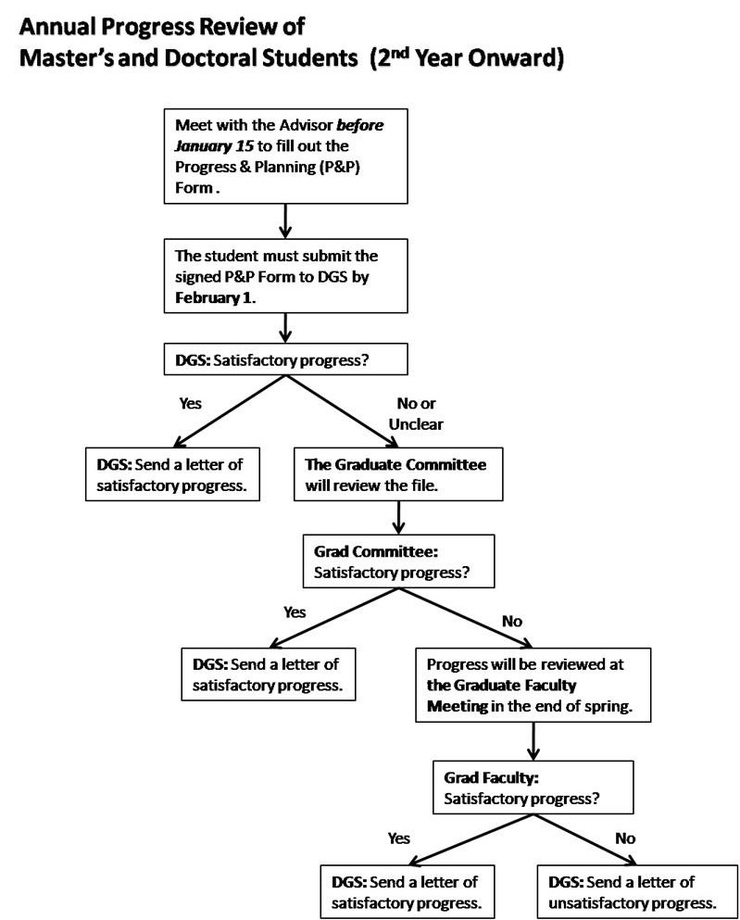

Annual Review

To facilitate students’ progress in the program, doctoral students are required to meet with their interim advisor or Advisory Committee at least once a year to complete an annual progress review. This review should be completed by February 1 following the end of the fall semester. To facilitate this review, students should fill out or update the Doctoral DPPR Form (available from the Department’s

Administrative Assistant), listing the courses taken to date, grades received, and other information related to degree progress (e.g., thesis proposal defense plans, thesis defense plans). One copy shall be filed with the DAA, one copy should be sent to the DGS, and other copies distributed to the advisor and committee members.
It is important that this document be filed by February 1, as information about student progress is used to evaluate requests for continued departmental financial assistance (teaching and research assistantships) for the coming academic year.
DPPR Forms will be reviewed by the DGS. Students without any problems will receive a letter of satisfactory progress by the DGS. In the event that problems in student progress are noted, the Graduate Committee will review his/her file and recommend a necessary course of action. When a Departmental discussion seems warranted, the Graduate Committee may decide to schedule a Graduate Faculty meeting at the end of the spring semester to discuss graduate student progress. The DGS will write a letter to the student and her/his advisor informing them of the Graduate Faculty’s concern and inquiring about steps the Department might take to address the problem.

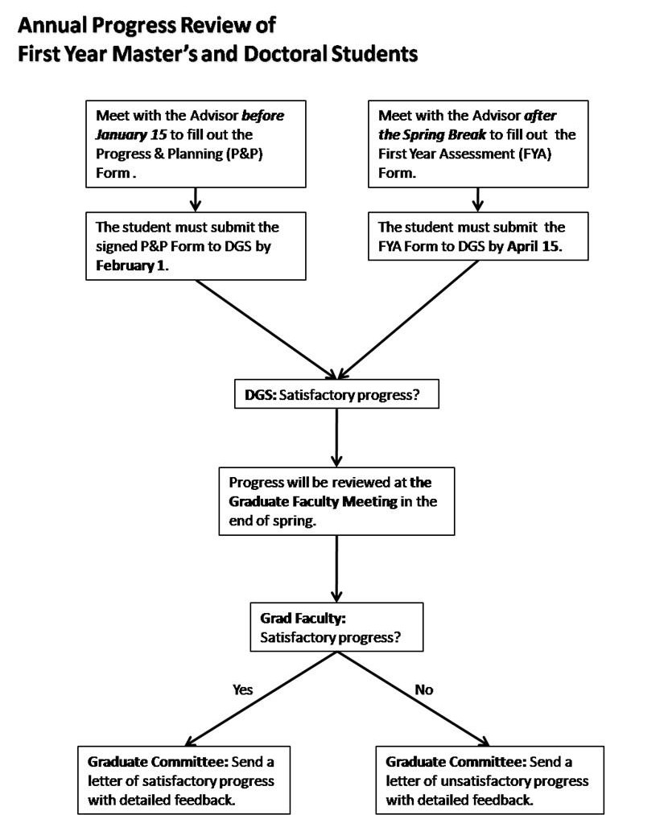

Progress Assessment of First Year Students

First year doctoral students normally do not have much information to be evaluated in the beginning of the spring semester. Besides the DPPR Form to be submitted to the DGS by February
1, they are required to submit to their advisors by the first day after the Spring Break a brief personal narrative statement which reflects on student progress in the graduate program. The short narrative must provide insight on the following: perceived main academic achievement(s) and challenge(s), TA/RA experience, prospective collaborations with faculty and fellow graduate students, departmental socialization, and any other issue(s) deemed important by the student. The statement must feature a SOC680/780 section. In this section, the student provides a statement, specifying what they might work on in SOC680/780, the timeline for completion of the SOC680/780 project, and ideas on prospective advisor/committee members, particularly their Chair.
The advisors then write their brief responses to the statements and schedule a meeting with each of the advisees to discuss the document and address any questions and/or concerns that the advisees may have about the graduate program, degree requirements, professional development, etc. Student’s personal narrative statement and the response of his/her advisor must be submitted to the DGS by April 15.
The Graduate Committee will schedule a Graduate Faculty meeting at the end of the spring semester to discuss their progress. The Graduate Committee will provide more detailed feedback to these students at the early stage of their graduate student career at the University of Kentucky and suggest any adjustments necessary to improve their performance.

Area of Specialization

As soon as possible after beginning the Ph.D. program, the student, in consultation with the Advisory Committee, will choose an area of specialization. This area of specialization may be changed with the approval of the Advisory Committee before taking the qualifying examination. Changes in the student’s area of specialization may result in changes in the student’s program requirements and delays in the qualifying exam. Such changes may require changes in the student’s Advisory Committee membership. Consult the DGS if committee membership must be changed.
The total minimum number of credit hours required in the area specialization is twelve. Credit hours are obtained through successful completion of formal courses in sociology, formal courses in related disciplines, and through independent study courses. Students who have completed the Master’s in Sociology at the University of Kentucky may apply course credits earned in the Master’s program to the PhD specialization area where appropriate. Students who receive the Master’s degree from another institution may apply up to nine credit-hours to the total of 39 credit hours in the program, with a maximum of six credit-hours taken elsewhere applied to the specialization area. Such “carry-in” credit arrangements must be approved by the DGS in consultation with the Graduate Committee. Students will be asked to supply syllabi for evaluation of equivalence of course content to aid in committee deliberations about “carry-in” credit issues.

The Comprehensive Assessment Examination

All doctoral students must successfully pass a comprehensive assessment (CA) upon completion of the core coursework in social statistics and theory. Students who pass the CA will be permitted to continue to the qualifying exam and dissertation proposal phase of the doctoral degree program. Students who fail to pass the CA will be permitted to retake the exam up to twice. After this point, they will not be permitted to continue in the doctoral degree program. In addition to serving as a test of preparedness for doctoral study, the CA will be used as one artifact for assessment of the doctoral program in sociology.
The comprehensive assessment has three broad goals.
1. To assure that students are prepared for doctoral study. The comprehensive assessment will allow faculty to make this determination earlier in the graduate career than is possible using only the qualifying examination. In addition, because the assessment is graded anonymously by committee,
decisions about fitness for doctoral study based on the CA will be more standardized and objective than the qualifying exam process. Ideally, this will save time and effort on the parts of both students and faculty in some cases.
2. To remove the assessment of broad statistical and theoretical mastery from the qualifying exam. This will allow students at the qualifying exam stage to focus more narrowly on theoretical, methodological, and substantive knowledge that is directly related to the dissertation project, thereby avoiding long delays between the qualifying exam and dissertation proposal defense and reducing time to degree completion. The required length of the qualifying exam will be scaled back to reflect the removal of broad statistical and theory assessment.
3. To assist with assessment of the doctoral program per the new procedures required by the Graduate
School for SACS accreditation.
Assessment: In the CA essay answers, students must demonstrate that they have sufficient knowledge and understanding of sociological theories, concepts, and social statistics that are fundamental to the discipline. Students will be required to develop sound arguments based in sociological theories and to
read and interpret sociological research in a critical manner. The CA will be comprised of two sections – theory and statistics – and will cover content that students are expected to have mastered in the core theory and statistics course sequences. For each section of the exam, students will answer two questions, including one required and one elective. For electives, students will choose one of two questions to answer.
All students who have successfully completed the core theory (i.e. SOC 651 and SOC 751) and statistics (SOC/PS 572 and SOC/PS 681 or equivalent) sequences will be eligible to take the CA. Consequently, most full-time students will be ready to take the exam after their first year of coursework.
The exam will be given the week prior to the beginning of each fall semester, and a retake will be given the week before the beginning of the spring semester. Procedures for both exams will be identical as described below. Students will take the exam together as a cohort, where applicable. Part-time students and those moving from the MA to the PhD program, will take the exam upon completion of their core coursework either in the fall or spring semester.
The exam will take place over the course of two consecutive days in a pre-specified location with assigned laptops without WiFi access. The exam will be closed-book. The statistics section will be written from 9:00am-12:30pm on the first day. The theory section will be written from 9:00am-12.30pm on the second day, for a total of 3.5 hours per section. A hard copy of the appropriate CA section will be distributed at 9:00am each morning of the exam. For the retake, the exam will only last one hour and forty five minutes (from 9:00am-10:45) if the student is retaking only one exam question.
The depth and breadth of CA answers will be consistent with the format of the exam and the time limitations (see the format requirements below). Each student will receive a grade of pass or fail for each section by a committee of four faculty members (two theory faculty and two methods faculty). Decisions to pass or fail will be made by committee and based on meeting minimum numeric thresholds corresponding to demonstration of proficiency on core graduate curriculum. This will be the same committee that developed the CA questions. Moreover, every effort will be made to ensure that faculty who taught the required courses in a given cycle serve on the CA committee. Grading will be blidnly reviewed and graded by the Comprehensive Exam Committees. Students will only be required to retake sections of the assessment or the specific question(s) that were not passed successfully. Results will be available within three to five weeks of the test date, depending on the cohort size. No feedback will be provided to students who pass the exam. Detailed and constructive feedback regarding specific areas for improvement will be provided to students who fail the exam to assist them in preparing for the retake. These students are also welcome to seek additional feedback from faculty on the Comprehensive Exam Committee, as needed. The time frame for sharing exam results and the approach to grading and feedback described above also applies to the exam retake process. Anonymity in grading cannot be assured when only one student is (re)taking the exam.

Students entering the PhD program from another MA program can request a waiver from specific required courses that they have taken previously. In special circumstances, waivers may be granted by the Graduate Committee based on a review of syllabi from relevant prior coursework. However, students requesting a waiver must still demonstrate proficiency by taking the applicable section of the CA (theory or methods) upon entering the PhD program. In other words, coursework may be waive d, but the CA will not. Thus, in most cases it is advisable for students to, at minimum, audit the waived course in preparation for the CA.

The Qualifying Examination

The purpose of the qualifying exam is to demonstrate knowledge, synthesis, and the critical evaluation of key sociological concepts, arguments, and findings within two areas of specialization.
All Ph.D. students are required to take a qualifying examination comprised of written and oral components. The exam covers two areas of specialization. Consistent with the Graduate School rules, qualifying exams (written and oral) can cover any material deemed appropriate by the student’s advisory committee. To help students prepare for the qualifying examination, core reading lists should be made available in specialization areas by the advisory committee, often in consultation with the student.
The student’s advisory committee will create, administer, and evaluate the written qualifying exam and administer and evaluate the compulsory oral exam. The Department authorizes two exam procedures. First, the written exam can be closed book and last up to eight hours per day. This closed book exam will occur within seven working days, with one day allocated for each exam area. Second, the written exam can be a take-home open book exam to be completed in fourteen calendar days upon receiving the questions.
The written portion of the qualifying exam will include questions in the two specialization areas with some choice offered to the student (some questions may be required). The recommended number of questions to be answered for both the take-home and the open-book exam format is two questions per exam area, for a total of 4 questions. For the take-home option, students will be expected to write approximately 12-15 page responses to each question, excluding references. The total page count of the exam will not exceed 60 pages, excluding references. The exam responses will be double-spaced, with 1 inch margins, using 12 point font.
Although the primary purpose of the qualifying exam is to assess depth and breadth of knowledge in two substantive sociological areas, it is expected that the student will develop their dissertation proposal in concert with their qualifying exam preparation. The student is strongly encouraged to submit and defend their dissertation proposal as soon as possible after the qualifying exam defense, ideally within one semester after this defense (please refer to the Guidelines for Satisfactory Progress of ABD students for more information on this timeline).
The student will notify the DGS of the proposed timetable for the written and oral exams once the Advisory Committee has approved the timetable. Such notification should indicate which exam procedure will be used. A qualifying exam begins once a student receives the questions and must follow through to an oral exam.
• Students must have successfully passed the Comprehensive Assessment Examination before the qualifying exam may be taken, as well as all courses in the student’s two specialization areas.
• All “Incompletes” must have been removed.

• Before the student may schedule the qualifying exam, the permission of the Advisory Committee must be obtained by the student.
• The qualifying exam cannot be held until approval from the Graduate School has been received by the DGS.
• The oral portion of the exam must be held within 2 weeks from the date of the written portion of the exam.
• SOC 767, residency credit will be applied for a qualifying examination taken at any time during the first semester of enrollment in this course.
• Classes must be in session, for the student to sit for the exam.
Upon passing the qualifying examination, the student officially becomes a “candidate” for the Ph.D. and proceeds to the dissertation stage of the program. If a student fails the qualifying exam on the first attempt, the student’s Advisory Committee will require the student to do additional work to prepare for taking the exam again (e.g., additional courses or directed readings). Upon completion of these additional requirements, the student should request and be granted a second qualifying exam. Scheduling requirements for the second exam are the same as scheduling requirements for the first exam.
• If a student fails the qualifying exam on the first attempt, written permission of the student’s Advisory
Committee must be obtained by the student prior to any decision to switch to a new form of exam.

• If a student fails the qualifying exam on the first attempt, the student will not be permitted to take a second exam before 4 months have passed; a second exam must be taken before 12 months have elapsed.
• A student is permitted two opportunities to pass the qualifying exam. If the student fails both attempts to pass the qualifying exam, the student will be dismissed from the program.

Pre-Qualifying Time Limit

Students will be required to take the qualifying examination within five years of entry into the program. Extensions up to an additional three years may be requested. Extensions up to twelve months may be approved by the Dean of the Graduate School upon receipt of a request from the DGS. Requests for extensions longer than twelve months must be considered by Graduate Council and will require the positive recommendation of the DGS, the chair of the student’s doctoral advisory committee, and a majority vote of Graduate Faculty in the program. If the qualifying examination has not been passed at the end of five years, or at the end of all approved time extensions the student will be dismissed from the program.
This new time limit applies to all programs, but the graduate faculty of a doctoral program (or group of programs) has the option to petition Graduate Council for a shorter or longer time limit. If approved, this modification will then apply to all doctoral students in that program.

Time Limit for Doctoral Degrees

All degree requirements for the doctorate must be completed within five years following the semester or summer session in which the candidate successfully completes the qualifying examination, but extensions up to an additional 5 years may be requested for a total of 10 years. Extensions up to 1 year may be approved by the Dean of the Graduate School. Requests for extensions longer than 1 year must be considered by Graduate Council. All requests should be initiated by the DGS. If approved, extensions

longer than one year will require a retake of the qualifying examination. Failure to pass the re- examination will result in the termination of degree candidacy; a second re-examination is not permitted. Failure to complete all degree requirements within 10 years of initially taking the qualifying examination will also result in the termination of degree candidacy. All pre- and post-qualifying residency requirements must again be met if the student subsequently seeks readmission to the doctoral program.

The Dissertation

THE PROPOSAL
When the student and the Chair of the student’s Advisory Committee feel that the student’s dissertation plans have been sufficiently developed, the student will draft a formal proposal, in consultation with other members of the Advisory Committee. When the student and the Chair of the Advisory Committee agree that the proposal is ready for official review, the student will schedule a meeting of the Advisory Committee for the formal proposal hearing.
At least one week before the proposal hearing, the student

• submits a copy of the proposal to the DGS.

• submits a one-page notice of the hearing and an abstract of the proposal to the DAA.
• makes a complete copy of the proposal available for interested faculty, in the office of the DAA.
The proposal hearing is chaired by the Chair of the student’s Advisory Committee, and all members of the Sociology faculty are invited and given the opportunity to comment on the proposal. At the conclusion of the hearing, the Advisory Committee will vote to approve or disapprove the proposal.
• If approved by a majority, the title page of the proposal will be signed by all members of the
Advisory Committee.

• The Chair of the Advisory Committee will transmit the signed proposal to the DGS to be permanently placed in the student’s file.
• If approval of the proposal is not given, another proposal hearing, which follows the same schedule requirements as the first hearing, will be held after suitable revisions.
WRITING THE DISSERTATION
The student’s Advisory Committee will supervise the student’s work during preparation of the
dissertation, with the Chair of the Committee taking major responsibility.

• The dissertation will be prepared in the format used in journals published by the American
Sociological Association.
• The student will consult the Office of Admissions and Records in the Graduate School and follow that office’s requirements regarding the dissertation’s format.

The Final Oral Examination

The final oral examination is conducted by a committee appointed by the Dean of the Graduate School. This committee consists of the Chair of the student’s Advisory Committee, the other members of the student’s Advisory Committee, and an outside reader appointed by the Dean of Graduate Studies.
The exam includes, but is not limited to, a defense of the dissertation. A majority vote of the full committee determines the outcome of the exam. In the event of a tie vote, the candidate fails. In the event

of failure of the final exam, a second exam will be scheduled if recommended by the student’s Advisory
Committee and if approved by the Dean of the Graduate School. A third exam is not permitted.
Upon passing the final oral examination, the student has 60 days from the final exam date to make any revisions, additions, and corrections required by the examining committee, and to deliver two copies of the dissertation in final form to the Graduate School, with the signatures of the Chair of the Advisory Committee and the DGS. If this deadline is not met, the candidate must undergo a second examination.
• Each graduating student must pay dissertation fees, payable at the University Billings and Collection office. (Authorization forms to pay dissertation fees are issued at the Graduate School in Room 105 of the Gillis Building.)
• The student must supply to the DAA one unbound copy of the dissertation for the Department library. (This is in addition to the two unbound copies required by the Graduate School.)

Proposed Revisions in the Doctoral Curriculum

During the 2014-15 academic year, the University will review our proposals to revise the Master’s and doctoral programs in Sociology. Students who entered the program in prior to the approval date can choose to complete the program either the current or new requirements. The proposed revisions in the PhD program in Sociology include:
1. Students must complete a total of 36 hours of coursework, including: (a) 18 hours for the core courses in Theory, Methods, and Statistics, (b) 3 hours for research design and practicum, and (c) 15 hours for electives.
2. Students must pass the preliminary (or revised comprehensive assessment) examination on sociological theory and social statistics during the second year.
3. Students must also successfully complete defend their 2nd year research paper (in journal-length) by the end of the second year to demonstrate their competency in sociological methods and research (IMPORTANT: Need to see specific details below)

Core Requirements
* New course; † Revised version of the existing course

Course No. Course Title Hrs. Semester
Offered

Prerequisites

SOC 681/PS572

SOC 781

Quantitative Data Analysis I 3 Fall Undergraduate statistics course

Quantitative Data Analysis II 3 Spring SOC 681/PS 572

Various Any approved method course(s) 6 Various SOC 681/PS 572
SOC 651 Classical Sociological Theory 3 Fall Undergraduate theory course
SOC 751 Contemporary Sociological Theory 3 Spring SOC 651
SOC 680† Social Investigation 2 Fall SOC 681/PS 572, SOC 781/PS 672, SOC 651, SOC 751
SOC 780 Special Problems in Sociology 1 Spring SOC 680
In order to streamline the Master’s and PhD degree programs, the purpose and required components
of the final examination need to change. Since all graduate students will be admitted to the PhD degree program from the fall semester of 2015, the Master’s final examination process must be restructured to determine which students will exit our program with a Master’s degree and which ones will proceed in the doctoral degree program. To achieve that goal, we will require all graduate students to take the Comprehensive Assessment Examination, offered in the fall semester of the second year, and complete the second year paper as the final examination.

1. Comprehensive Assessment Examination. In the beginning of the fall semester of the second year, all the students must take the comprehensive assessment exam to test their knowledge and skills in sociological theory and social statistics. The result of the comprehensive assessment exam will be: (a) Pass to move up to the doctoral level, (b) Pass to graduate with the Master’s level, and (c) Fail. If they fail
in the first try, students can retake the exam in the end of the 2nd fall semester to pass to graduate with the Master’s level or to move up to the doctoral level. In the spring semester of the second year, all the students, who passed the Comprehensive Assessment Exam, must complete the second year research
paper (see below).
2. Second Year Research Paper.
The final examination of the Master’s degree consists of successful oral defense the second year research paper, which “must take place no later than eight (8) days before the last day of classes of the semester in which the degree is to be awarded” (The Graduate School Bulletin Part 1, p. 46). This second year paper will also be a degree requirement for the doctoral degree and used
to assess students’ understanding of sociological theory and methods and research skills as well as their knowledge on the content. Only those students who complete the second year paper can continue with the doctoral program in Sociology. Students who wish to obtain a MA degree or exit from the program with a MA degree must use the completion of the second-year paper as the Final Examination for MA degree in Sociology.

Some Specifications
Students who enter the doctoral program with a Sociology MA in hand will use the required SOC 680/780 sequence to prepare one of the following: 1) dissertation pilot study; 2) a dissertation proposal draft; 3) a journal-length paper to submit for presentation or publication; or 4) any other project approved by the student's advisor.

Students who enter the doctoral program without a Sociology MA in hand are required to use the SOC 680/780 sequence to write the 2nd year paper. The 2nd year paper must be defended by the spring of year 2.

Note: If the student wants a UK MA in Sociology, they must conform to Graduate School regulations.

Advisory Committee:
Each student working on the 2nd year paper must form an advisory committee by the end of the second fall semester. The advisory committee must consist of: (a) that student’s faculty advisor and b) two additional faculty that conform to the Graduate School regulations regarding advisory committees for MA degrees. The faculty advisor is encouraged to consult with the DGS when selecting the sociology faculty reader as a means to allow for a more
fair distribution of graduate committee assignments among the SOC graduate faculty.

Special Provisions
Waiver. Students who have completed a MA/MS in Sociology in another program can request a waiver for the core course requirements to DGS. DGS will conduct an initial review to determine what documentations need to be submitted by the student. Then, the Graduate Committee will review the documents to determine whether or t to approve the waiver request. Even with course waiver(s), all students are required to take and pass the Comprehensive Assessment Exam.
Part-Time Students. Part-time students are allowed to take SOC 680/780 sequence AFTER their successful passing of the Comprehensive Assessment Examination. It is strongly advised that part-time students take the Exam by no later than the fall semester of the third year in order to meet the 5-year pre- qualifying time-limit set by the Graduate School. They must discuss with both DGS and their major advisors about the timing of fulfilling the second year paper.

Funding

Philosophy of Funding

It is the policy of the Department to try to provide funding for all qualified students upon entry into the graduate program at the Master’s and doctoral levels. Those students who do not receive funding upon entry are eligible to be considered for funding in subsequent years. Decisions about funding are made in yearly evaluations of graduate student progress, academic performance, and participation in departmental life (e.g., attending departmental colloquium and talks). Students must make systematic progress toward their degrees to ensure continued funding.

Assistantships and Fellowships

In addition to Graduate School scholarships and fellowships, the Department normally awards a number of half-time service (20 hours per week) teaching and research assistantships. The actual number of available assistantships varies from year to year. All graduate students in Sociology are eligible to apply. Preference is given to superior students whose career interests converge with the particular purposes for which the assistantships have been established. Three full-time research assistantships come from the Department of Community and Leadership Development, and other research assistantships may come from department member’s grant awards and research centers on campus.

Time Limits on Support

Students who hold assistantships are expected to make satisfactory progress toward the degree. The time limit guidelines for departmental funding support are as follows:
• Master’s students--a maximum of two years of “departmental” support.

• Ph.D. students--a maximum of four years of “departmental” support for those entering with the M.A. from another institution.
• Students who complete the M.A. or M.S. degree at UK and who have received two years of “departmental” support during that period are eligible for an additional three years of support in the Ph.D. program.
“Departmental funding” is defined as any teaching and research assistantship or fellowship provided through university funding sources (e.g., either recurring departmental assistantships, assistantships supported by grants secured by university faculty or staff, or university non-service fellowships). The
only exception to the funding time limit is that students may be employed on grant funding after expiration of time limits outlined above upon request of the principal investigator.
It is possible that a student may find it necessary to take time off from her/his studies. If so, the student must inform their Advisory Committee and the DGS of their intentions to take time off. Assuming the student has been making adequate progress, the Department will not count this time-off period against their funding time limit. However, the Department cannot guarantee that funding will be available when the student returns.

Adequate Progress and Priorities for Funding

Each year students who receive funding from the Department as well as those requesting funding for the coming year will be evaluated by the Graduate Committee to determine the student's priority for continued or future funding. Criteria for minimal progress include the following:

GRADES
Students are expected to maintain a minimum B (3.0) average before an advanced degree is awarded. Specific policies regarding academic probation and termination have been developed by the Graduate School for students whose average falls below a 3.0. This is a Graduate School requirement. In addition there is a Department requirement that all required theory and methods courses be completed with a minimal grade of B and that graduate students who receive grades of C or below in as many as 9 credit hours of course work in Departmental or cross-listed course work shall be dropped from the graduate program in Sociology. Low grades or maintaining only a minimal GPA can affect ranking for funding.

REQUIRED COURSES
Students are expected to take required courses in theory and methods/statistics at the first opportunity they are qualified to take them. Postponement of required courses can affect ranking for funding.

ACADEMIC LOAD
The typical academic load is 9 hours for full-time enrollment. First year students must complete 18 hours of course work, including completion of appropriate required course work. The Graduate School stipulates that students funded with a Teaching Assistantship or a Research Assistantship take no more than 9 hours per semester. If a student wishes to request a waiver of this maximum number of hours for a given semester, she or he should contact the DGS.

INCOMPLETES
The Department strongly recommends minimal use of incompletes. Incompletes should be requested sparingly, and except in extraordinary circumstances, must be completed within one semester. Students taking an incomplete must sign a contract with the instructor specifying requirements for completion of the course and when it will be completed. Failure to meet the terms is grounds for turning in a grade of E. Overall, excessive numbers of incompletes or failures to complete them promptly, except in unusual extenuating circumstances (severe health problems, family/personal emergencies, etc.), will be viewed as failure to make adequate progress.

THESIS OR MAJOR PAPER
The Department expects timely completion of the Master’s thesis/paper. Full-time, funded Master’s students must successfully defend their thesis proposal by the third week of their fourth semester in the program in order to be considered for funding in the following year as a doctoral student in the Department. An award of funding in the student’s third year is contingent upon: (1) successful completion of the Master’s degree prior to the beginning of the student’s third academic year in the program; and (2) admittance to the Ph.D. program. Students who are admitted to the Ph.D. program with funding but who do not actually complete the thesis on time will have their funding terminated if they fail to complete the thesis by the end of their fifth semester in residence.

TA/RA PERFORMANCE
TA and RA performance includes the evaluation of all funded students by their supervisors. This evaluation will included in the overall evaluation of a student’s progress and can affect the student’s ranking for funding. Students may include a statement evaluating their assistantship experience, performance, and/or supervision.

PROFESSIONAL ORIENTATION/ACTIVITY
Students should become involved in efforts to demonstrate professional activity as evidence of ongoing career development. These may include attending designated departmental seminars, committee meetings, presenting papers at conferences, writing/publishing papers, writing grant proposals, etc. as appropriate to the student’s stage in the program. Ranking for funding will consider such professional activity.
Appeals: Any student who has been denied continued funding as a result of the review process may ask for clarification from the DGS or the Graduate Committee. An appeal to the Committee may be made upon the recommendation of the student’s faculty advisor.

Summer Teaching by Graduate Students

PAY CATEGORY
Doctoral students who teach a summer course will be categorized as “GA” (graduate assistant). Any pre-qualifying student who chooses to enroll for a summer course can receive a tuition waiver for up to 3 credit hours.

ELIGIBILITY
Doctoral students who are eligible for TA/RA funding have the first priority in teaching summer courses. Students who exceed their funding eligibility will be considered for summer teaching positions only if the department is unable to staff these positions with eligible students. Summer teaching will NOT be counted against the total length of funding eligibility.

SELECTION PROCESS
Doctoral students who wish to teach a summer course must first submit an application form for summer teaching to the DGS by September 15. The Graduate Committee will rank these applications and submit recommendations for summer teaching assignments to the Department Chair.

MINIMUM REQUIREMENTS

• Students show clear evidence of satisfactory academic progress (e.g., completing courses) and professional development (e.g., TA/RA evaluations).
• Students have a master’s degree and have completed SOC 603: Teaching Seminar (or equivalent course approved by the Graduate Committee).
• Students must defend their master’s thesis in the fall semester prior to the summer they plan to teach.

PRIORITY (IN ORDER)
• Students who have completed the qualifying examination;

• Students who have completed all course work and are planning to take the qualifying exam in the following fall;
• Students who have not yet taught a course;

EVALUATION
Each doctoral student who teaches a summer course will be evaluated by a faculty member in accordance with the Graduate School’s requirement. His/her performance evaluation will be included as evidence of professional development in our doctoral program.

IMPORTANT NOTE
Doctoral students who are assigned to teach in summer are disqualified from consideration for Beers
Summer Research Mentoring grants.

Funding for Travel
Graduate student participation in presenting their research at professional conferences is an important part of graduate education in the Department of Sociology. As the amount and availability of funding to support graduate student travel are variable year to year, the following are guidelines intended to assist the Department Chair in awarding funding for graduate student travel to present their research at professional conferences.

All sociology graduate students seeking travel funding must submit a completed copy of the Graduate Student Travel Funding Request Form to the Director of Graduate Studies (DGS) at least 2 months prior to the conference.

The Department has limited funds to support Conference travel for graduate students. Students will be expected to car pool, stay at the less expensive conference hotels, and share rooms. Departmental stipends will help defer the costs of conference travel but may not cover the entire cost of most conference trips (depending on location).

The students that receive travel funding will organize practice sessions prior to the professional conference. The practice sessions will provide students with the opportunity to receive feedback and strengthen their presentations. Every semester, the DGS will share the names of the students that receive travel funding in order to facilitate the setup of the practice sessions. GSO will help promote the practice sessions among graduate students and the Professional Development Chair will help promote the practice sessions among faculty to ensure that there’s student and faculty presence at the practice sessions.

Graduate Student Awards

The Department of Sociology at the University of Kentucky has three awards given to graduate
students each year. All award winners will be honored at the department’s Annual Awards Ceremony.

• The Graduate Student Teaching Award recognizes the outstanding contributions its graduate students make to its undergraduate teaching mission. All graduate students who have taught their own course in our undergraduate curriculum are eligible. The award consists of (1) an individual plaque and (2) placement of the recipient’s name on a plaque to be displayed in the department. Those interested in applying should submit six copies of their vita and teaching portfolio to the DGS.

• The John A. O’Donnell Award is for a graduate student near graduation who has “demonstrated an exceptional degree of creativity and intellectual vigor” and are recognized by “virtually everyone (faculty and students)” as “truly outstanding.” All graduate students who are ABD (i.e., those who have successfully defended their dissertation proposal) are eligible. The award consists of (1) an individual plaque, (2) a one-year subscription to a major sociological journal, and (3) placement of the recipient’s name on a plaque to be displayed in the department.
• The Howard Beers Summer Fellowships support collaborative research efforts between faculty and graduate students. All graduate students are eligible. The award consists of a one-time stipend of
$2,000. Those interested in applying should assemble a packet of materials that includes six copies of a cover letter indicating with which faculty member the study is being undertaken, the nature of the graduate student-faculty collaboration, the dissemination goals of the study (e.g., presentation at a professional meeting, publication in a peered review journal, applied or extension distribution, etc.), a short proposal (5 to 10 pages) describing the study, the student’s vita, and a supporting letter from the faculty mentor about the faculty member’s mentoring role and the study’s importance for the student’s career. Preference will be given to students who have not previously received the Beers award.
Additional awards are available depending on departmental funding. They include The Incentive Awards for Major Research Grant Applications for students applying for grants from the National Science Foundation, Social Science Research Council, National Institute of Justice, National Institute of Health, the National Institute of Drug Abuse, or Fulbright. The Methodological Excellence Grant for students to go to the Inter-University Consortium for Political and Social Research Summer Training or other Institutes. Students should check with the Awards Committee Chair for details on application procedures and the amounts of these awards.

Appendices

A. Master’s Program Learning Outcomes B. Doctoral Program Learning Outcomes C. Degree Planning & Progress Form

Appendix A. Master’s Program Learning Outcomes

Students completing the Master’s program in Sociology will:
1. Demonstrate an ability to use sociological concepts and theoretical traditions to analyze social issues or processes;
2. Demonstrate an ability to design and execute a sociological research project;
3. Demonstrate conceptual and practical competency in social statistics, including the ability to:
a. accurately evaluate the strength and validity of quantitative empirical evidence;
b. compute and interpret descriptive statistics, measures of association, and multivariate statistics, including multiple regression;
c. identify solutions to data limitations;
d. determine whether quantitative methods constitute the best fit for a particular research question and identify which statistical techniques to employ;
e. accurately use social statistics in their research to develop empirical evidence or test sociological theory; and
f. incorporate social statistics into their instructional and engagement activities;
4. Demonstrate an ability to effectively communicate sociological explanations of specific social phenomenon through visual and oral presentations; and
5. Demonstrate an understanding of the ethical standards of the discipline.

Appendix B. Doctoral Program Learning Outcomes

Students completing the doctoral program in Sociology will:
1. Demonstrate a comprehensive knowledge of sociological theory through;
a. an ability to integrate the work of classical and contemporary sociological theorists in their writings;
b. an ability to apply fundamental sociological concepts to their own scholarly work;
c. an understanding of theoretical traditions in sociology; and
d. an ability to articulate how their own research challenges, supports, or builds on existing theory.
2. Demonstrate expertise in at least one core substantive area within the discipline;
3. Demonstrate an ability to position their own research within the wider discipline through:
a. an ability to formulate a research question and hypothesis grounded in the sociological literature;
b. knowledge and appreciation of the strengths and weaknesses of different methodologies;
c. an ability to effectively apply these techniques in their independent research projects;
d. an understanding of theoretical traditions in sociology; and
e. an ability to articulate how their own research challenges, supports, or builds on existing theory and methodology.
4. Demonstrate conceptual and practical competency in social statistical analysis, including the ability to:
a. accurately evaluate the strength and validity of quantitative empirical evidence;
b. compute and interpret descriptive statistics, measures of association, and multivariate statistics, including multiple regression;
c. identify solutions to data limitations;
d. determine whether quantitative methods constitute the best fit for a particular research question and identify which statistical techniques to employ;
e. accurately use social statistics in their research to develop empirical evidence or test sociological theory; and
f. incorporate social statistics into their instructional and engagement activities.
5. Demonstrate an understanding of the ethical standards of the discipline.

Doctoral (Ph.D.) Degree Planning and Progress Form

This form provides a summary of graduate level work earned for the Ph.D. degree in Sociology. Please submit a copy to the DGS and to your advisor by February 1st (before the review of graduate students).

1. Name of Student:

2. Date of Initial Enrollment in Sociology Graduate Program at UK: Semester
Year

3. Master’s Degree: College/University:

Major:
Year

Other College Degrees: School:
Area/Level:
Year

4. Schedule of Courses:

Theory:
A. Required Courses: Semester and Year Exempted by Graduate Committee
Planned or Taken

Sociology 651 (3 hours)

Sociology 751 (3 hours)

Methods and Statistics:

Sociology 681 (3 hours)

Sociology 682A (3 hours) Quantitative (Survey Research
or Comparative/Historical)

Sociology 682B (3 hours) Qualitative

B. Area of Specialization 1:

Semester and Year If taken at another University: Course Number and Title: Planned or Taken Where taken: Person approving:

C. Area of Specialization 2:

 |  | Semester and Year |  | If taken at another University:
Course Number and Title: |  | Planned or Taken |  | Where taken: Person approving:

D. Additional Courses

Semester and Year If taken at another University:

Course Number and Title: Planned or Taken Where taken: Person approving:

6. Advisory Committee Members: (3 required) Replacements: (if applicable)

(Chair)

(Co-chair [ ], check if so)

Outside Member:
Department:

7. Qualifying Examination:

Semester Year Day Semester Year Day

Date Planned:
If Exam is Re-taken:

Written exam taken:
Written re-taken:

Date oral exam taken:
Oral exam re-taken

8. Dissertation:

Title:

Date Dissertation Prospectus Successfully Defended:

Please complete the following ‘chapter summary’ or submit a one page statement on the progress of your dissertation, from which your chair will make an assessment of progress toward finishing the Ph.D. degree.

9. Financial Assistance Received (since becoming Ph.D. Student):

Semester | Year | Fellowship Name | TA  (Course No.) | RA  (Project Title & Supervisor Name)

10. Applications for Research Grants

Date  Submitted | Grant/Fellowship Program Name | Amount | Received?  (Yes or No)

11. Papers Presented at Conferences (list most recent titles)

Date  Presented | Paper Title | Conference Name | Location

12. Academic Department Functions Attended in Last Year:

Date  Attended | Function Name | Type  (e.g., Seminar, Workshop) | Sponsor

13. Papers Submitted for Publication

Date  Submitted | Paper Title | Journal/Book Name | Result

14. Awards Received:

Name of Award: Date:

15. Teaching Experience:

A. Teacher Training Course Taken:

Name of Course:
Date:
Instructor:

B. Courses Taught (one course per line) Semester (F / SP / SM) / Year(s)

As a Teaching TA:

As a PTI:

Please sign and present this form to your faculty advisor at least a week before the annual review.

15. Student Signature:
Date:

16. Advisor Signature:
Date:

ABD Doctoral (Ph.D.) Degree Planning and Progress Form

Please submit a copy to the DGS and to your advisor by February 1st (before the review of graduate students).

1. Name of ABD Student:

a. Area of Specialization 1:

b. Area of Specialization 2:

2. Date of Initial Enrollment in Sociology Graduate Program at UK: Semester Year

3. Advisory Committee Members: (3 required) Replacements: (if applicable)

(Chair)

(Co-chair [ ], check if so)

Outside Member:
Department:

4. Date Qualifying Examination taken:

5. Date Dissertation Prospectus Successfully Defended:

6. Dissertation Title: _

7. Applications for Research Grants

Date  Submitted | Grant/Fellowship Program Name | Amount | Received?  (Yes or No)
8. Papers Submitted for Publication

Date | Paper Title | Journal/Book Name | Result

Submitted

Please sign and present this form to your faculty advisor at least a week before the annual review.

9. Student Signature: _
Date:

10. Advisor Signature:
Date:

Appendix E. Learning Contract for an Independent Study Course

Date:
Semester:
Year:

Student Name:
Student No.:

Course Number & Title:
Credits:

Local Address:
Phone:

Major:
Current GPA:
Grading: [ ] Letter [ ] Pass/Fail

Year: 1st
2nd
3rd
4th 5th
Graduate

Faculty Member Directing Project:

Title of Project:

1. Timetable for Work and Completion (indicate frequency of consultation):

2. Briefly describe your learning objectives or the goals to be accomplished in this course:

3. Briefly describe the methods you will use to accomplish these goals (e.g., materials you will read, interview, analysis of data, etc.):

4. Briefly describe the ways the faculty member directing this project will evaluate your progress and the products that you intend to produce with your work.

Signatures:

Student Project director Department Chair

